***Species Name* (16pt, Bold)**

***Facesoffungi Number:* FoF 00010 (** point: get number from Administrator)**

***Species Name*** Authority, Index Fungorum Number: IF XXXXX (Publication details of the species with Index Fungorum number**,** 12pt bold species name)

(Possible synonyms, 10pt – use Index Fungorum format)

**Description (**Description with measurements of sexual and asexual state of species**)**

*Saprobic* on the surface of dried twigs, less common on leaves. **Sexual state:** *Ascomata* 380–450 × 370–430 μm ( = 395 × 380 µm, n = 10), solitary or scattered, initially immersed, becoming erumpent to near superficial, globose to subglobose, broadly or narrowly conical, coriaceous, smooth-walled, ostiolate. *Ostiole* usually broadly papillate, central ostiolar canal filled with periphyses and covered with setae. *Setae* brown to reddish-brown, darkened at the base, septate and tapered towards the apex. *Peridium* 40–70 μm ( = 45 µm, n = 20) wide, comprising two types of cells, outer cells of 1–2 layers of heavily pigmented cells of *textura angularis*, inner layer composed of small, light brown to hyaline cells of *textura angularis*. *Pseudoparaphyses* not observed. *Asci* 300–400 × 130–160 μm ( = 345 × 140 µm, n = 20), 8-spored, bitunicate, fissitunicate, clavate to sub-cylindrical, with a short, broad pedicel, thickened and rounded at apex with a distinct ocular chamber surrounded by a large, distinct, apical ring. *Ascospores* 78–96 × 27–34 μm ( = 88 × 30 µm, n = 40), biseriate to overlapping triseriate, ellipsoidal with broadly rounded ends, hyaline to light brown when immature, becoming brown to chestnut brown when mature, muriform with 5–6 transverse septa and single longitudinal septa in one or all cells, constricted at the septa, smooth-walled, relatively thick-walled, with a 5–9 μm thick mucilaginous sheath.**Asexual state:** not observed, but see notes.

**Material examined:** SWEDEN, on leaves of *Anthoxanthum* (Poaceae), 7 August 1951, J. Ax. Nannfeldt (UPS 170980, **neotype**). (Details of the material examined, what is the family of host plant)

**Distribution:** (Write description about the places of species distribution)

**Sequence data:** (Sequence data from type or extype or study this collection came from)

**ITS:** JN943649.1 (ITS1/ITS4); **LSU:** JN940093.1 (LROR/LR5); **SSU:** JN940960.1 (NS1/NS4); **EF1a:** DQ497607.1 (983/2218R); **RPB2:** DQ497614.1 (fRPB2-SF/fRPB2-7cR)

**Notes:**(Notes on species, Importance of species to humans or ecosystem, Quarantine significance, Biochemical importance of species, chemical diversity or application)

**Fig. x. *Pyrenophora phaeocomes*** (**neotype**). A, B Ascomata on host specimen. C Close up of ascoma. D Side view of ascoma with neck covered with setae. E, F Sections of ascomata. G Section of peridium. H Ostiole, with central periphyses. J Light brown seta. K-M Asci with 8 ascospores, distinct ocular chamber and apical ring. N-Q Mature and immature muriform ascospores. Scale bars: E-F=200 μm, G=30 μm, H=80 μm, J=50 μm, K-M=50 μm, N-Q=15 μm.

(Label and measurement of the plate, mention species name and number)

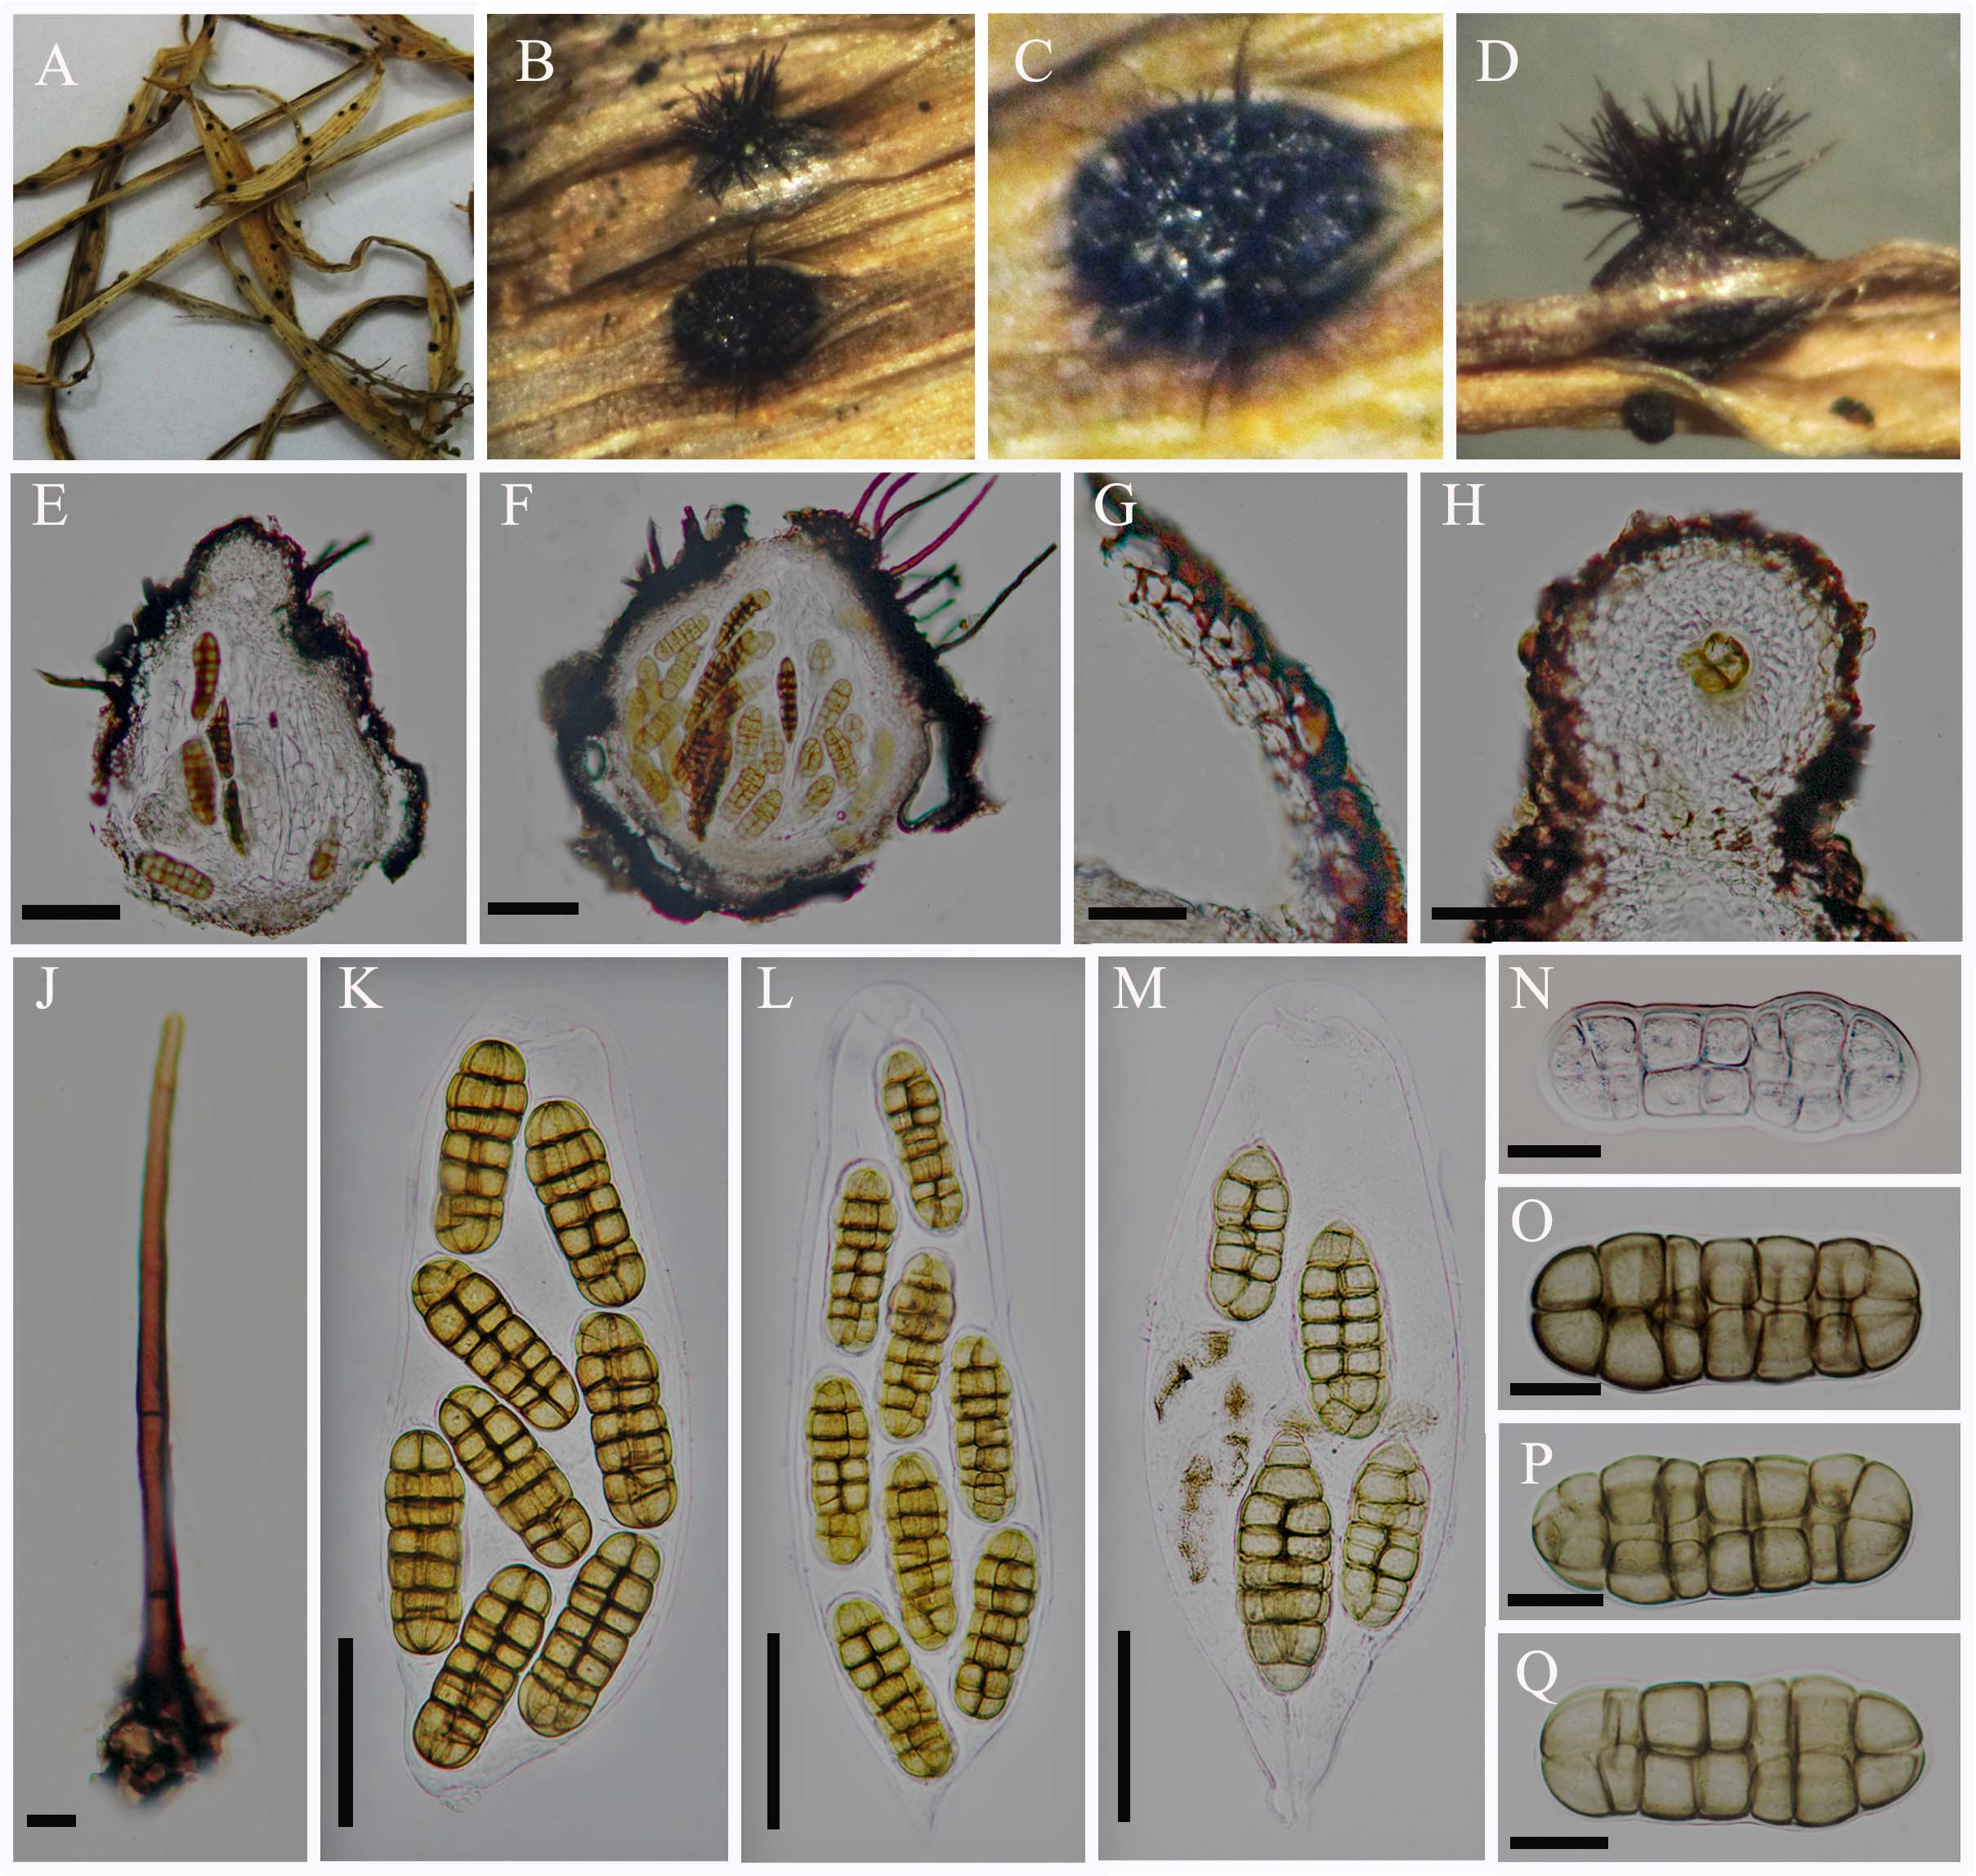

(Photographic plates)