Order Name (Times New Roman, 16pt, Bold)
Facesoffungi Number: FoF 00010* (* get number from Administrator)

Citation:
Mapook A, Hyde KD, Dai DD, Li J, Jones EBG, Bahkali AH, Boonmee S. 2016 – Muyocopronales, ord. nov., (Dothideomycetes, Ascomycota) and a reappraisal of Muyocopron species from northern Thailand. Phytotaxa 265: 225-237. (Citation 10pt)

Order Aothority, ord. nov., Index Fungorum number: IFXXXX (Publication details of the species with Indexfungorum number, 12pt bold species name)

(+ possible synonyms if available)

Saprobic, common on the surface of dried twigs, less common on leaves. Sexual morph: Ascomata superficial, coriaceous, appearing as circular, flattened, brown to dark brown spots covering the host, without a subiculum, with a poorly developed basal layer. Ostiole central without setose or hairy appendages. Peridium mostly comprising pseudoparenchymatous cells of textura angularis. Hamathecium comprising filiform, septate, branched, hyaline pseudoparaphyses. Asci 8-spored, bitunicate, saccate or broadly obpyriform, sometime oval to obovoid, with or without an ocular chamber. Ascospores multi-seriate to irregularly arranged, hyaline, oval to obovoid with obtuse ends, aseptate with or without granular appearance. Asexual morph: Undetermined. (Morphological descriptions of the order)
Type family: Family (see reference for description) (Publication details of the type species with Indexfungorum number)
Notes:
Phylogenetic tree for Muyocopronales

Fig 1. (Legend for the phylogenetic tree, mention Bootstrap support values and the outgroup – extype strains should be in bold)

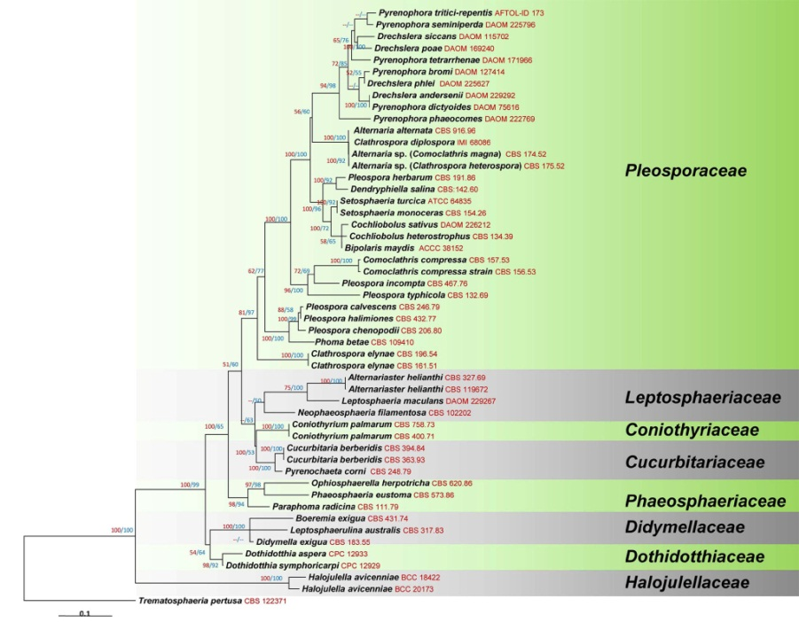
(Phylogenetic tree 01-Phylogenetic placement of the genus within the family)

Families list (give a list of families in the order)

