Genus Name (Times New Roman, 16pt, Bold)
Facesoffungi Number: FoF 00010* (* get number from Administrator)

Citation:
(Citation 10pt)

Pyrenophora Authority, Index Fungorum Number: IF 4596 (Publication details of the species with Indexfungorum number, 12pt bold species name)

(+ possible synonyms if available)

(Descriptions of sexual and asexual states of the genus)
Saprobic on the surface of dried twigs, less common on leaves. Sexual state: Ascomata immersed, becoming erumpent to near superficial, solitary or scattered, globose to subglobose, broadly or narrowly conical, smooth-walled, ostiolate. Ostiole papillate, covered with brown to reddish-brown setae, which are darkened at the base. Peridium comprising 2–4 layers of brown, thick-walled cells of textura angularis. Hamathecium lacking pseudoparaphyses. Asci 8-spored, bitunicate, fissitunicate, clavate to sub-cylindrical, with a short, broad pedicel, with a distinct ocular chamber surrounded by a large apical ring. Ascospores 2–3-seriate, muriform, constricted at the septum, smooth-walled, surrounded by a mucilaginous sheath. Asexual state: hyphomycetous. Conidiophores macronematous, mononematous, sometimes caespitose, straight or flexuous, often geniculate, unbranched or in a few species loosely branched, brown, smooth in most species. Conidiogenous cells polytretic, integrated, terminal, frequently becoming intercalary, sympodial, cylindrical, cicatrized. Conidia solitary, in certain species also sometimes catenate or forming secondary conidiophores which bear conidia, acropleurogenous, simple, straight or curved, clavate, cylindrical rounded at the ends, ellipsoidal, fusiform or obclavate, straw-coloured or pale to dark brown or olivaceous brown, sometimes with cells unequally coloured, the end cells then being paler than intermediate ones, mostly smooth, rarely verruculose, pseudoseptate (description of asexual state from Ellis 1971).

Type species: Species Name Authoroty, Index Fungorum Number: IF XXX (Publication details of the type species with Indexfungorum number, 12pt bold type species name)

(+ Possible synonyms of type species if available)

Notes: (any notes on genus)
Importance and role:
Importance of genus to humans or ecosystem

Industrial relevance and applications

Quarantine significance

Biochemical importance of the genus, chemical diversity or applications

Phylogenetic placement of xxxx species

Fig. 2. RAxML tree based on a combined dataset of ITS, LSU and GPDH. Bootstrap support values >50% are shown above or below the branch. The tree is rooted with Pleospora herbarum. The original isolate numbers are noted after the species names. Bold indicates ex-type strains. (Legend for the phylogenetic tree, mention Bootstrap support values and the outgroup. Extype strains should be in bold)

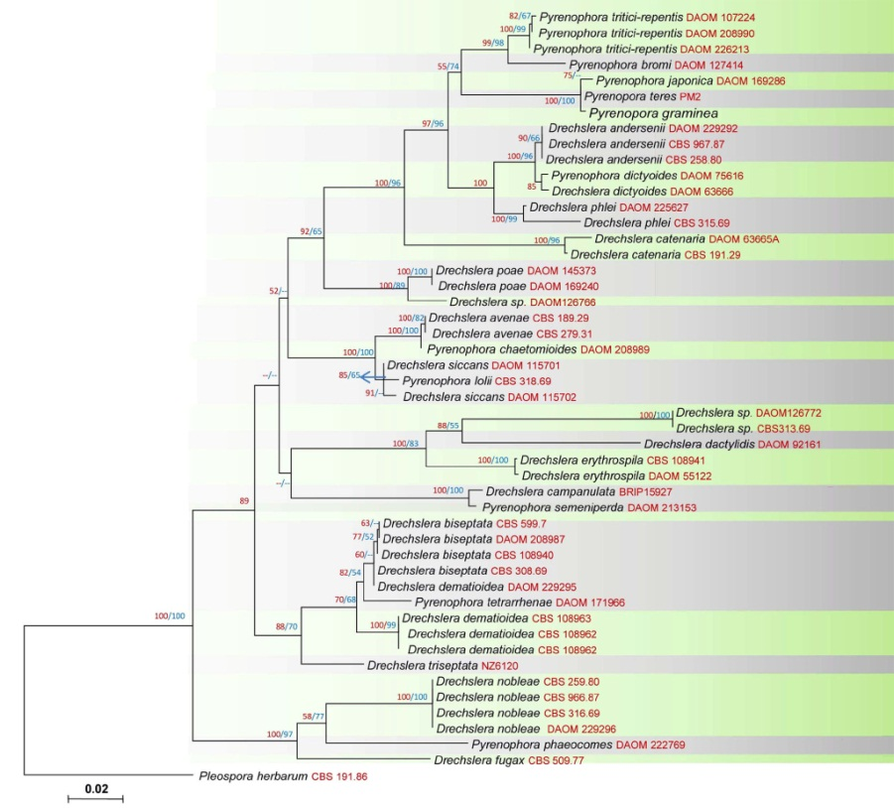
(Phylogenetic tree 02-Phylogenetic placement of the species within the genus)

Species list (list the species in this genus)

